Dalton Murray

Systems Analysis and Design

INT 6123 – Systems Analysis and Design

Dr. Andrew Makar

October 15, 2023

**Midterm**

**Task 1 - Using Lucid Chart, develop a Use Case diagram identifying at least 5 use cases for the customer interacting with the website**

The instructions on the midterm say to export as PNG and attach to word file, I will do so, however, I will also attach separately as a PDF as previously instructed for past assignments.

PNG:

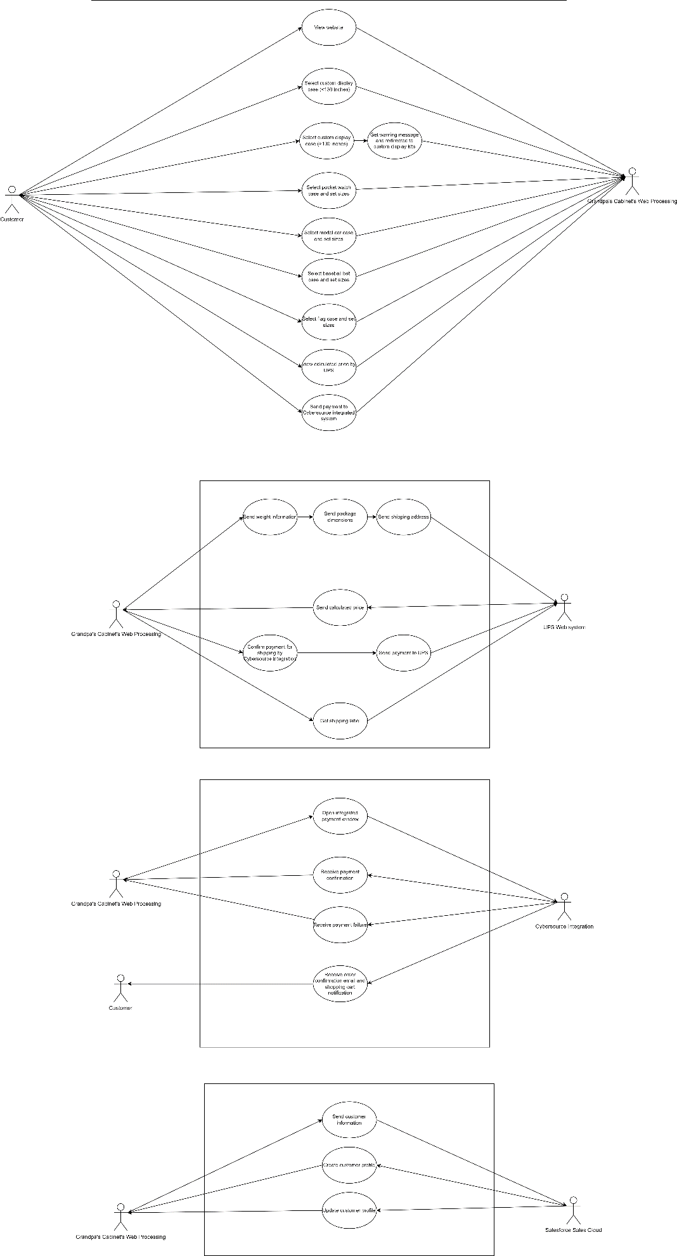

PDF: Attached separately as PDF.

**Task 2 - Using Lucid Chart, develop the Order Process flow Activity Diagram**

**Develop the activity diagram for automating the order form processing and credit card interaction. Take into account credit card failure.**

The instructions on the midterm say to export as PNG and attach to word file, I will do so, however, I will also attach separately as a PDF as previously instructed for past assignments.

PNG: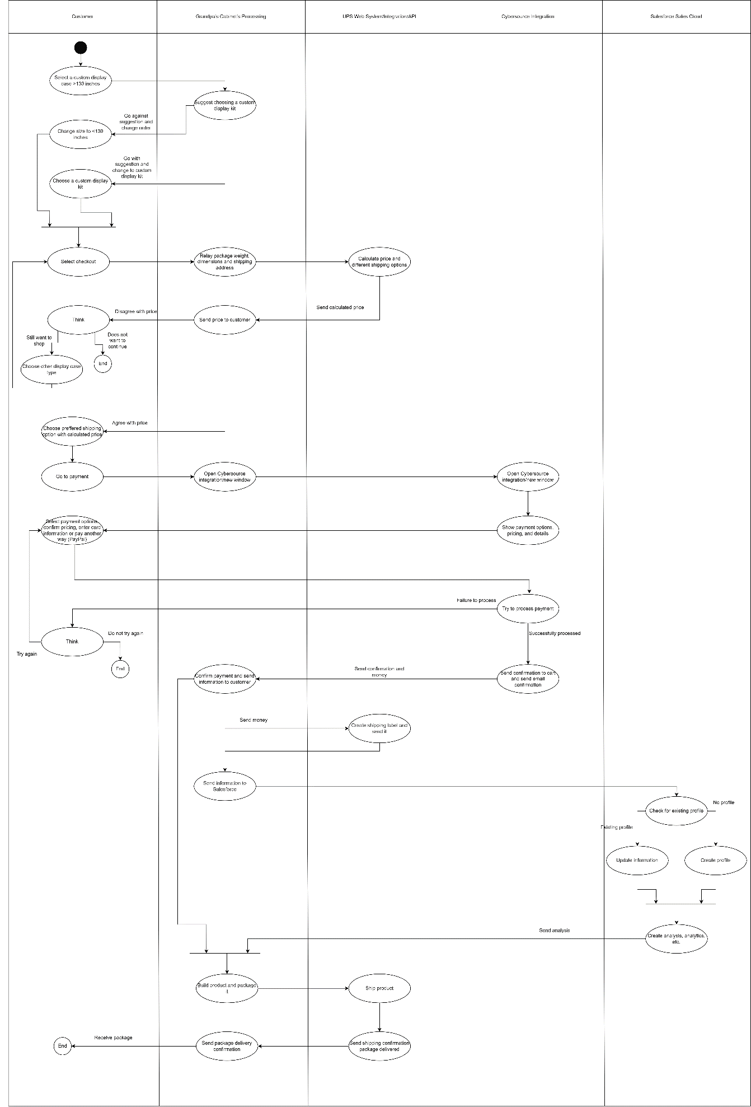

PDF: Attached separately as PDF.

**Task 3 – Develop the Domain Class model for the system**

The instructions on the midterm say to export as PNG and attach to word file, I will do so, however, I will also attach separately as a PDF as previously instructed for past assignments.

PNG:

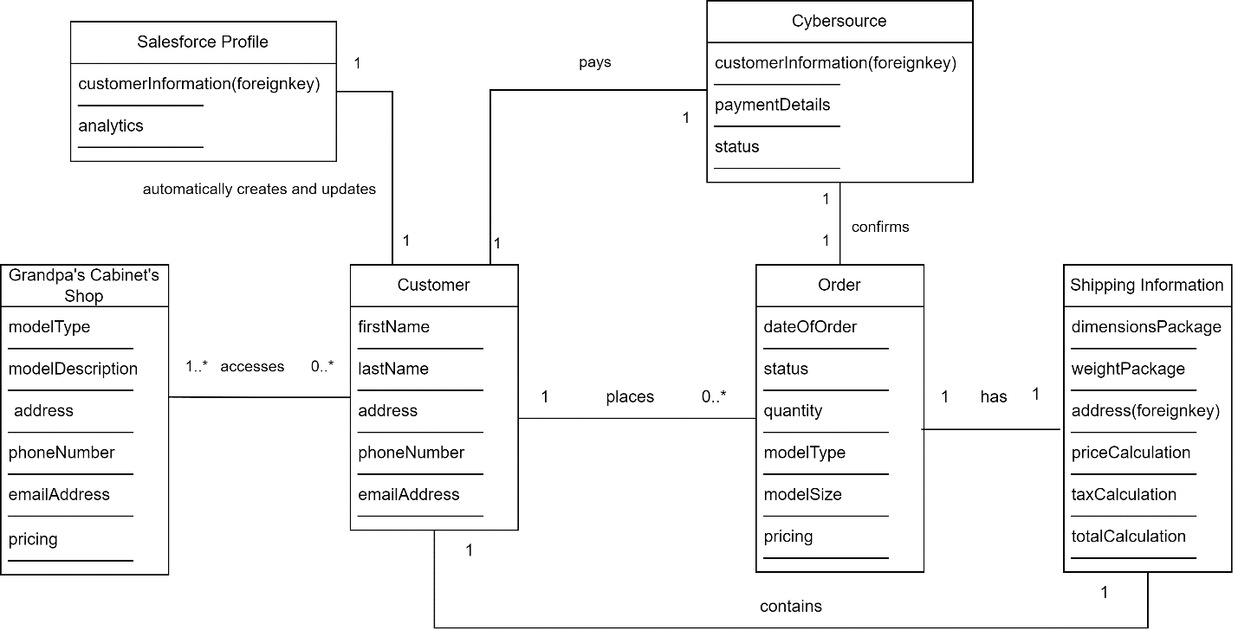

PDF: Attached separately as PDF.

**Task 4 - Pick one of the use cases from the Use Case diagram and write a Use Case specification (use the template provided in Module 5) that identifies the steps, inputs, outputs, assumptions, etc.**

|  |  |  |
| --- | --- | --- |
| **Use Case Name** | Place order | |
| **Scenario** | A customer is placing an order | |
| **Triggering Event** | A customer finds a product and tries to place an order | |
| **Brief Description** | A customer has searched through the different options, chosen a display case or kit which they want and then has selected different options and are going through the checkout process | |
| **Actors** | Customer, Grandpa’s Cabinet’s, Cybersource, and Salesforce | |
| **Stakeholders** | Customer, Grandpa’s Cabinet’s, Cybersource, and Salesforce | |
| **Preconditions** | The customer must be needing a display case or kit | |
| **Postconditions** | The customer has ordered a display case or kit, Grandpa’s Cabinet’s is making the display case or kit, and is shipping the case or kit | |
| **Flow of Activities** | **Actor** | **System** |
| 1. Views Grandpa’s Cabinet’s store  2. Has selected a display case they want to order  3. Has chosen different options for the display case that are available such as sizing  4. Presses checkout  5. Confirms shipping speed and personal details for shipping such as name, address, phone number  6. Presses pay now  7. Confirms information and puts in payment details  8. Receives failure/success message and email  9. Receives display case | 1.1 Display different display cases, models, and kits  4.1 Logs information  4.2 Sends information to UPS for price calculation  4.3 Receives calculated price from UPS and shows it to customer  6.1 Sends personal information to Cyebrsource new window to automatically fill in name, address, phone number  6.2 Cybersource prompts to confirm information or change it  7.1 Processes payment (failure/success)  7.2 Sends notification or failure or success  7.3 Sends email  7.4 Grandpa’s Cabinet’s confirms order with customer  7.5 Grandpa’s Cabinet’s confirms payment with UPS to print shipping label  7.6a Grandpa’s Cabinet’s sends information to salesforce  7.7 Salesforce creates/updates profile and performs analytics and sends to Grandpa’s Cabinet’s  7.6b Grandpa’s Cabinet’s makes case and ships it with UPS  7.8 Grandpa’s Cabinets confirms delivery with UPS |
| **Exception Conditions** | 7.1 Payment fails | |

**Task 5 - Knowing the system will be taking credit card transactions, identify and discuss how you will design security controls in the system. For each security control identified, describe how it will be used in this system design**

There is a minimum level of security which I always suggest. To begin, all of the websites and forms for Grandpa’s Cabinet’s, since they are web-based, will have an SSL/TLS certificate. This is to ensure that there is at least some basic level of security, and does not require any alterations with the actual systems other than potentially setting up automated alerts and renewals for the SSL/TLS certificate.

Secondly, there really is no reason not to ensure that all data being stored such as the customer’s name, address, email, phone aren’t hashed or encrypted in some way. This would require alterations to the system design, specifically the database of how we store the data, as well as ensuring that everything is getting hashed or encrypted correctly and then getting unhashed and unencrypted successfully.

Next, since we aren’t actually processing the payment ourselves but are allowing a third party to handle it, it would be a good idea to ensure that all data is end-to-end encrypted, meaning that the client handles hashing, encrypting and unhashing and unencrypting on their end, this hashed and encrypted data gets sent to us and then on our end we unhash and unencrypt it when and where necessary. This also means that we will not be storing any actual banking information in our databases, which is a good thing and limits our need for a higher level of security, however, there isn’t much of a reason to not include a higher base level of security though.

We should also ensure that the databases we have are only accessible by those who actually need the access, thankfully, since everything is either stored hashed or encrypted we don’t need to worry too much about who can access it since the only people accessing it should be the ones who are actually editing or modifying the tables as there would be no reason to give anyone read only access since they wouldn’t be able to actually read anything anyways. The amount of change necessary on the existing system design for this is not much as it would only require changing existing accounts permissions for what they can access in the databases.

We should also enforce at minimum 2FA with the customer’s phone number by text, I do not think, however, that we need to have a system setup for handling actual 2FA with a changing code in an actual authenticator. This would require a little amount of change on the existing system design so that they can log in and then need to get a code by text and then enter that so they can view an existing order or place an order.

For Salesforce, since I am not completely familiar with it, I am going to assume that the people who can access it can only see aggregated results and not individual results, so this means that we do not need to control too much access here and should only realistically give access to those who need to interact with it.

I believe with all of the controls I’ve listed that they should be more than well protected based on the company and its usage. I do not think that they need much higher levels of security control and there would be a limited number of attack vectors with the mentioned security controls.

**References**

Satzinger, J. W., Jackson, R. B., & Burd, S. D. (2016). Systems analysis and design in a Changing World (7e ed.). Cengage Learning.

I have neither given nor received unauthorized aid in completing this work, nor have I presented someone else's work as my own.

*Dalton Murray*